Tail dependence: AUDUSD and EURGBP
Method 19 / daily log returns / alpha=0.05 / Alpari D1 full available history

Study setup
Logical pair: AUDUSD , EURGBP
Broker symbols: AUDUSD_i , EURGBP_i
Snapshot: 2026-11-03_majors_alpari_D1
Timeframe: D1
Matched return window: 1999-01-06 to 2026-11-02 (UTC bar dates)
Matched return count n: 7198
Dropped unfinished last bar dated 2026-11-03 UTC after a tick-volume check against the prior complete day.
Uniforms: ranks/(n+1); alpha=0.05
Complete matched rows (Excel): AUDUSD-EURGBP_Tail_D1.xlsx
Complete matched rows (HTML table): AUDUSD-EURGBP_Tail_D1_data.html

Method carried forward
Tail dependence counts how often both legs sit in an extreme uniform tail together. Matched daily log returns of close, ln(close_t / close_t-1), become u_i = rank(x_i)/(n+1) and v_i = rank(y_i)/(n+1). At alpha=0.05, lower L_hat = (# u<=alpha and v<=alpha) / (# conditioning leg <= alpha); upper uses >= 1-alpha. Both conditioning directions are reported with numerator and denominator counts. Quotes are not inverted. L_hat(0.05) is a finite-sample frequency, not the asymptotic lambda. Same-sample Pearson r is a side check. This is not causation and not a trading signal.

Results
tail | cond | L_hat | num | denom
lower | EURGBP | 0.142061 | 51 | 359
lower | AUDUSD | 0.142061 | 51 | 359
upper | EURGBP | 0.111421 | 40 | 359
upper | AUDUSD | 0.111421 | 40 | 359
Pearson r on returns: 0.038173

Conclusion
Over 7198 matched daily rows for AUDUSD and EURGBP at alpha=0.05, lower L_hat conditioning on EURGBP is 0.1421 (51/359); conditioning on AUDUSD is 0.1421. Upper L_hat conditioning on EURGBP is 0.1114; on AUDUSD is 0.1114. Pearson r = 0.0382. These are finite-sample frequencies, not asymptotic lambda and not a trading signal.

Charts
Daily closes

Daily log returns

Uniforms with alpha lines
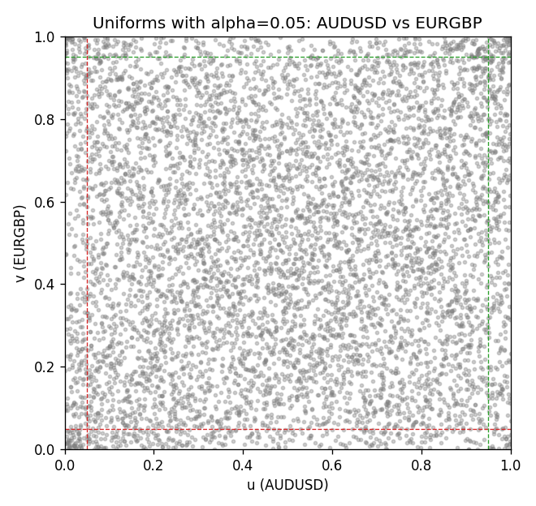

Data report
Every matched row is stored in the sibling Excel workbook named AUDUSD-EURGBP_Tail_D1.xlsx, including u and v. Embedding all rows as a Word table is impractical; this file holds column summaries and the first and last 15 matched rows.
Columns: time, AUDUSD_open, EURGBP_open, AUDUSD_high, EURGBP_high, AUDUSD_low, EURGBP_low, AUDUSD_close, EURGBP_close, AUDUSD_tick_volume, EURGBP_tick_volume, AUDUSD_spread, EURGBP_spread, AUDUSD_real_volume, EURGBP_real_volume, AUDUSD_log_return, EURGBP_log_return, u, v
Column summaries (matched calculation rows)
column | count | mean | std | min | 25% | 50% | 75% | max
AUDUSD_open | 7198 | 0.75202191 | 0.13526259 | 0.4785 | 0.6611175 | 0.731685 | 0.8091425 | 1.10284
EURGBP_open | 7198 | 0.78667202 | 0.09675257 | 0.5734 | 0.687325 | 0.83369 | 0.8651775 | 0.9769
AUDUSD_high | 7198 | 0.7560731 | 0.13582215 | 0.4878 | 0.6648025 | 0.7351 | 0.8153975 | 1.10795
EURGBP_high | 7198 | 0.7897492 | 0.09712763 | 0.5789 | 0.6894 | 0.836595 | 0.86804 | 0.9799
AUDUSD_low | 7198 | 0.74796393 | 0.1345766 | 0.4775 | 0.6578225 | 0.727775 | 0.804275 | 1.0975
EURGBP_low | 7198 | 0.7839722 | 0.09657024 | 0.5682 | 0.6853 | 0.831475 | 0.8627775 | 0.9661
AUDUSD_close | 7198 | 0.75206897 | 0.13524509 | 0.4786 | 0.661255 | 0.7318 | 0.8092725 | 1.10169
EURGBP_close | 7198 | 0.78671595 | 0.09675201 | 0.5735 | 0.687525 | 0.83375 | 0.865285 | 0.977
AUDUSD_tick_volume | 7198 | 77378.184 | 138156.24 | 109 | 5445.75 | 43349.5 | 71356.75 | 1234623
EURGBP_tick_volume | 7198 | 86961.088 | 145396.59 | 332 | 6520.25 | 44270 | 81329 | 1424684
AUDUSD_spread | 7198 | 30.809114 | 16.88495 | 0 | 13 | 30 | 50 | 50
EURGBP_spread | 7198 | 21.389692 | 19.14164 | 0 | 4 | 13 | 50 | 50
AUDUSD_real_volume | 7198 | 5.2442754e+09 | 1.2540657e+11 | 0 | 0 | 0 | 0 | 3.811512e+12
EURGBP_real_volume | 7198 | 2.7809077e+10 | 1.3507993e+11 | 0 | 0 | 0 | 0 | 3.5726265e+12
AUDUSD_log_return | 7198 | 2.054e-05 | 0.00754782 | -0.08602525 | -0.00386556 | 0.00027727 | 0.00415374 | 0.0806166
EURGBP_log_return | 7198 | 2.199e-05 | 0.00487197 | -0.03067367 | -0.00262256 | -0.00010006 | 0.00256155 | 0.06075387
u | 7198 | 0.5 | 0.28865507 | 0.00013891 | 0.25006945 | 0.5 | 0.74993055 | 0.99986109
v | 7198 | 0.5 | 0.28865504 | 0.00013891 | 0.25006945 | 0.5 | 0.74993055 | 0.99986109
First 15 matched rows (selected columns)
time | AUDUSD_log_return | EURGBP_log_return | u | v
1999-01-06 | 0.011836351 | -0.013303338 | 0.95846645 | 0.0080566745
1999-01-07 | 0.0088650256 | 0.011051402 | 0.91693291 | 0.98221975
1999-01-08 | 0.00031515916 | -0.004943862 | 0.50270871 | 0.11932213
1999-01-11 | 0.0072213815 | -0.0012752393 | 0.87748298 | 0.37463537
1999-01-12 | -0.0048608485 | 0.0033970309 | 0.20600083 | 0.80205584
1999-01-13 | -0.0078902098 | 0.00042381861 | 0.11126545 | 0.55035422
1999-01-14 | -0.002696916 | -0.0019793588 | 0.31212668 | 0.30823726
1999-01-15 | 0.007123101 | -0.0076715819 | 0.87345465 | 0.048617864
1999-01-18 | 0.00094592471 | 0.00071280921 | 0.54729824 | 0.5806362
1999-01-19 | 0.0072225153 | -0.0014261269 | 0.87762189 | 0.36143909
1999-01-20 | 0.0012507819 | 0.0019960086 | 0.56730101 | 0.70593138
1999-01-21 | 0.00078094498 | -0.00071240297 | 0.53604667 | 0.43200445
1999-01-22 | -0.012252745 | -0.0017118406 | 0.044033894 | 0.33185165
1999-01-25 | -0.0039591468 | -0.0054402425 | 0.24531185 | 0.10140297
1999-01-26 | 0.00047592608 | -0.00057438255 | 0.51368246 | 0.44895124
Last 15 matched rows (selected columns)
time | AUDUSD_log_return | EURGBP_log_return | u | v
2026-10-13 | 0.0035007712 | 0.00020130374 | 0.71232116 | 0.53076816
2026-10-14 | -0.0015193215 | 0.0011241873 | 0.38269204 | 0.62341992
2026-10-15 | -0.0075447063 | -0.00087557391 | 0.11793305 | 0.41269621
2026-10-16 | 0.0033906408 | -0.0020380844 | 0.70662592 | 0.30309765
2026-10-19 | 0.0050859986 | -0.00056950988 | 0.79511043 | 0.44964578
2026-10-20 | 0.0034620426 | -0.0035906254 | 0.71037644 | 0.18599806
2026-10-21 | 0.0036066384 | -0.00140647 | 0.71912766 | 0.36282817
2026-10-22 | -0.0012672558 | -0.0018743924 | 0.4006112 | 0.31712738
2026-10-23 | 0.0023765656 | 0.00082421033 | 0.63883873 | 0.5925823
2026-10-26 | -0.0032032829 | 0.00013133309 | 0.2835116 | 0.52215585
2026-10-27 | 0.0016669876 | -0.0019957343 | 0.59160995 | 0.30698708
2026-10-28 | 0.0040915541 | 0.00066967224 | 0.74663148 | 0.57744131
2026-10-29 | -0.0040915541 | -0.0011722209 | 0.23989443 | 0.38408112
2026-10-30 | 0.0010102376 | -0.0024205543 | 0.55049312 | 0.2682317
2026-11-02 | -0.0049184984 | 0.00089940465 | 0.20336158 | 0.60091679

